**Cassandra lab 4**

|  |
| --- |
| 1. **create key space killrvideo, replication params required** 2. **switch to key space killrvideo** |

.

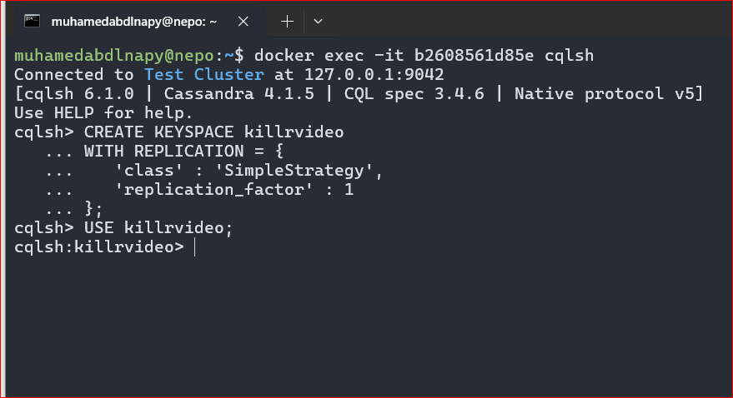

|  |
| --- |
| 1. **create table**   **CREATE TABLE IF NOT EXISTS videos (**  **video_id TIMEUUID,**  **added_date TIMESTAMP,**  **description TEXT,**  **title TEXT,**  **user_id UUID,**  **PRIMARY KEY(video_id)**  **);**   1. **Insert records of data into the table Videos**   **Video_id, added_date, description, title, user_id**  **2644c36e-14bd-11e5-839e-8438355b7e3a,'2011-10-05','Apache Cassandra is a high performance','DataStax Cassandra Tutorials',10d5c76c-8767-4db3-8050-e19e015b524c** |

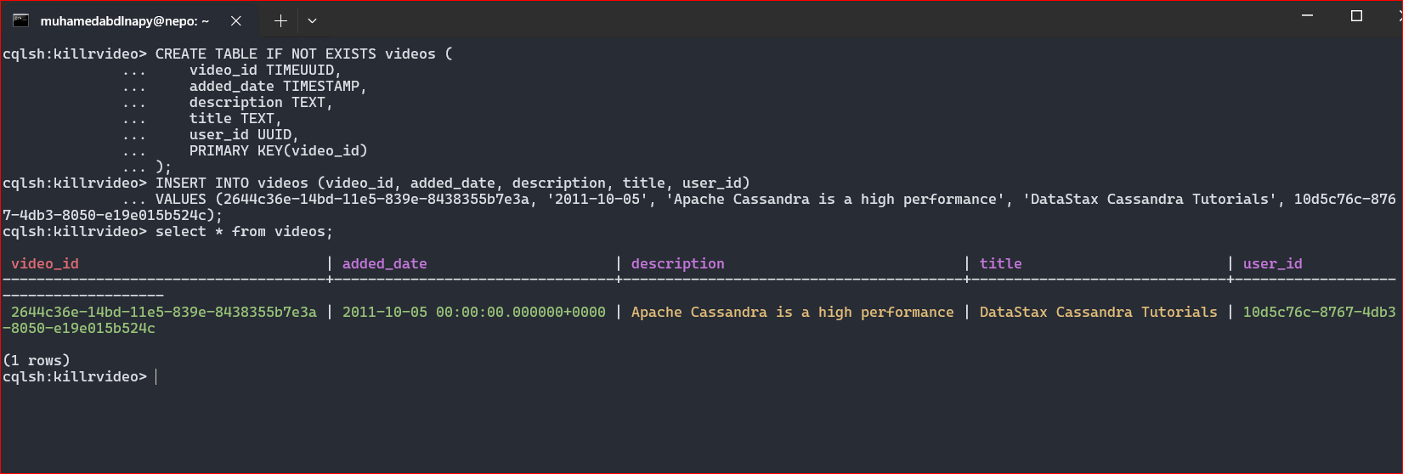

|  |
| --- |
| 1. **use the created keys pace killrvideo ,then**   **create table**  **CREATE TABLE IF NOT EXISTS videos_by_title_year (**  **title TEXT,**  **added_year INT,**  **added_date TIMESTAMP,**  **description TEXT,**  **user_id UUID,**  **video_id UUID,**  **PRIMARY KEY((title, added_year)) );**   1. **Insert records of data into the table videos_by_title_year**   **title,added_Year, added_date, description, user_id,video_id**   1. **'DataStax Cassandra Tutorials', 2011,5/10/2011,'Apache Cassandra', 10d5c76c-8767-4db3-8050-e19e015b524c,2644c36e-14bd-11e5-839e-8438355b7e3a** 2. **Display from video_by_title , title= DataStax Cassandra Tutorials and added_year =2011** |

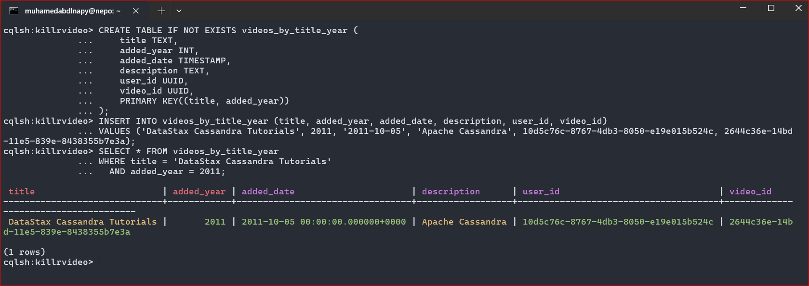

1. **update description = new cassandra when added_year = 2011 and title ='DataStax Cassandra Tutorials';**

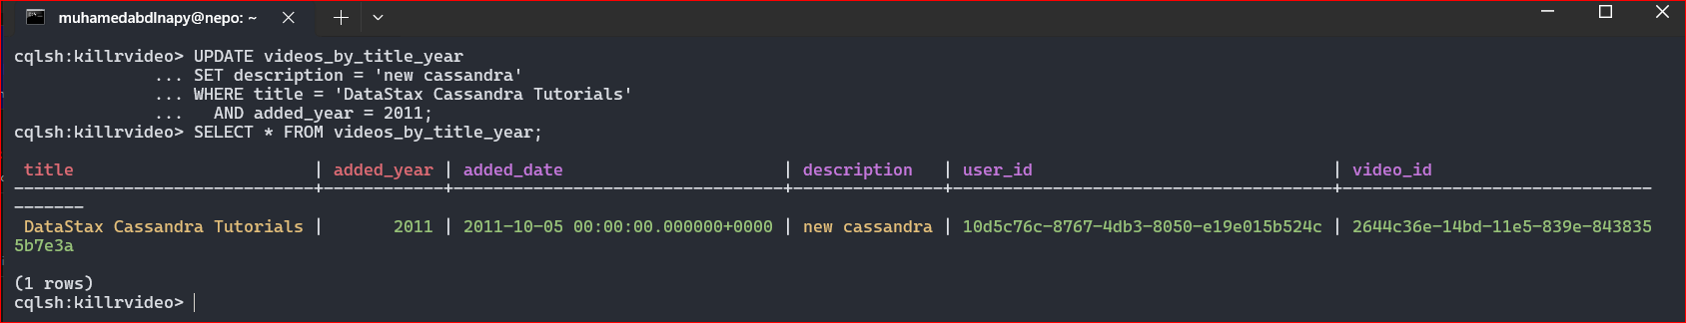

1. **delete added_date value when added_year = 2011 and title ='DataStax Cassandra Tutorials';**
2. **Display all from video_by_title**

